**TERM 2 2022 OPENER EXAM FORM 1**

**AGRICULTURE FORM ONE**

**DURATION-1HR 30 MIN (70 Marks)**

**Instructions: Answer all questions in the spaces provided**

**NAME ……………………………………………………………….ADM……………CLASS…………**

1. Define the following (6mks)

A) Agriculture ………………………………………………………………………………………………………………………………………

……………………………………………………………………………………………………………………………………………………………b)Floriculture……………………………………………………………………………………………………………………………………………………………………………………………………………………………………………………………………………………………………c)Apiculture………………………………………………………………………………………………………………………………………………………………………………………………………………………………………………………………………………………………………

2. Giving examples, explain why agriculture is both an art and science (6mks)

…………………………………………………………………………………………………………………………………………………………………………………………………………………………………………………………………………………………………………………………………………………………………………………………………………………………………………………………………………………………………………………………………………………………………………………………………………………………………………………………………………………………………………………………………………………………………………………………………………………………………………………………………………………………………………………………………………………………………………………………………………………………………………………………………………………………………………………………………………….

…………………………………………………………………………………………………………………………………………………………………………………………………………………………………………………………………………………………………………………………………………………………………………………………………………………………………………………………………………………………………………………………………………………………………………………………………………………………………………………….

3. Why is agriculture very important to the economic development of Kenya (5mk)

……………………………………………………………………………………………………………………………………………………………………………………………………………………………………………………………………………………………………………………………………………………………………………………………………………………………………………………………………………………………………………………………………………………………………………………………………………………………………………………………………………………………………………………………………………………………………………………………………………………………………………………………………………………………………………………………………………………………………………….

……………………………………………………………………………………………………………………………………………………………

4. Name and explain three methods of farming (6mks)

…………………………………………………………………………………………………………………………………………………………………………………………………………………………………………………………………………………………………………………………………………………………………………………………………………………………………………………………………………………………………………………………………………………………………………………………………………………………………………………………………………………………………………………………………………………………………………………………………………………………………………………………………………………………………………………………………………………………………………………………………………………………………………………………………………………………………………………………………………………………………………………………………………………………………………………………………………………………………………………………………………………………………………………………………………………………………………………………………………………………………………………………………………………………………………………………………………………………………….

5. Give the difference between the following

a) Olericulture and pomology (2mks)

…………………………………………………………………………………………………………………………………………………………………………………………………………………………………………………………………………………………………………………………b)Intensive farming and extensive farming (2mks)

…………………………………………………………………………………………………………………………………………………………………………………………………………………………………………………………………………………………………………………………c)Pastoralism and aquaculture (2mks)

…………………………………………………………………………………………………………………………………………………………….

……………………………………………………………………………………………………………………………………………………………

d)Plantation farming and ranching (2mks)

……………………………………………………………………………………………………………………………………………………………………………………………………………… …………………………………………………………………………………………………………

e)Small scale and large scale farming (2mks)

…………………………………………………………………………………………………………………………………………………………………………………………………………………………………………………………………………………………………………………………6.What are the advantages of shifting cultivation (3mks)

………………………………………………………………………………………………………………………………………………………………………………………………………………………………………………………………………………………………………………………………………………………………………………………………………………………………………………………………………………………

7a)What is soil profile? (2mks)

…………………………………………………………………………………………………………………………………………………………………………………………………………………………………………………………………………………………………………………………b)Below is a diagram of soil profile, label the parts A to E (5mks)

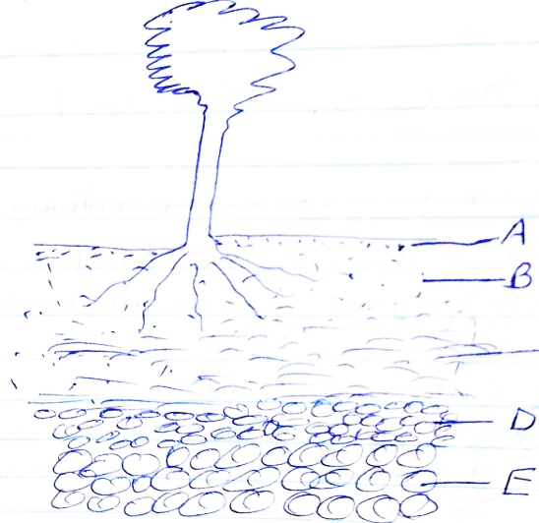

C

8.Name four aspects of rainfall that influence agriculture (4mks)

……………………………………………………………………………………………………………………………………………………………………………………………………………………………………………………………………………………………………………………………………………………………………………………………………………………………………………………………………………………………………………………………………………………………………………………………………………………………………………………

9.Name four factors that influence soil formation (4mks)

……………………………………………………………………………………………………………………………………………………………………………………………………………………………………………………………………………………………………………………………………………………………………………………………………………………………………………………………………………………………………………………………………………………………………………………………………………………………………………………

b)Name the three agents of weathering (3mks)

…………………………………………………………………………………………………………………………………………………………………………………………………………………………………………………………………………………………………………………………

…………………………………………………………………………………………………………………………………………………………………………………………………………………………………………………………………………………………………………………………

10.Name the biotic factors that influence agriculture (4mks)

……………………………………………………………………………………………………………………………………………………………………………………………………………………………………………………………………………………………………………………………………………………………………………………………………………………………………………………………………………………………………………………………………………………………………………………………………………………………………………………

11.State the effects of HIV/ AIDS on agriculture (4mks)

……………………………………………………………………………………………………………………………………………………………………………………………………………………………………………………………………………………………………………………………………………………………………………………………………………………………………………………………………………………………………………………………………………………………………………………………………………………………………………………

12.Match column A to the correct answer in column B (4mks)

|  |  |
| --- | --- |
| A | B |
| 1)Domestication | Deals with the use and maintenance of farm tools machinery and structures |
| 2)Crop pathology | Production of crops on cultivated land |
| 3)Crop farming | When crops and animals become dependent to man for existence |
| 4)Agricultural engineering | Study of crop diseases |

b)Name the constituents of soil (4mks)

……………………………………………………………………………………………………………………………………………………………………………………………………………………………………………………………………………………………………………………………………………………………………………………………………………………………………………………………………………………………………………………………………………………………………………………………………………………………………………………………………………………………………………………………………………………………………………………………………………………………………………………………………………………………………………………………………………………………………………………………………………………………………………………………………………………………………………………………………………